Vacation homework

Ukg

!_ s'g} $ j6f t/sf/Lsf lrq slkdf 6fF; / gfd klg n]v .
@_ ltxf/df s–s;sf] k"hf ul/G5 < n]v.
#_ tnsf lrqx? Afgfpm / /ª e/ M df}/L, afF;, km"n, 5ftf
$_ ltd|f] kl/jf/sf ;b:ox?sf] gfd g]kfnL / c+u|]hL (English) df n]v .
5) Write the name of any 5 flowers in English or Nepali that one found around your house.
6) Count and write the number of following things.
1) Windows of your house
2) Spoons in your kitchen
3) Friends of your class
4) Family members
5) Pillows in your bedroom
s[kof Vacation homework 5'§} skLdf u/fOlbg'xf]nf .

Vacation homework
Std-I

!_ cfˆgf] h'Qf kfln; ug{ l;s .
@_ cfˆgf] df]hf / ?dfn w'g l;s .
#_ cfˆgf kl/jf/sf ;b:osf] gfd English / g]kflndf n]v .
4) Buy a new English story book and read new stories.
5) Count the number of given shapes.
i) Triangle ii) Circle iii) Square iv) Rectangle
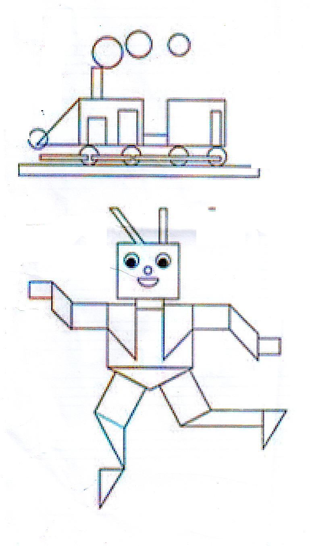

s[kof Vacation homework 5'§} skLdf u/fOlbg'xf]nf .

Vacation homework

Std-II

!_ cfˆgf] h'Qf kfln; ug{ l;s .
@_ cfˆgf] df]hf / ?dfn w'g l;s .
#_ bz}F / ltxf/df ltdLn] vfPsf vfg] s'/fsf gfd n]v .
$_ cfˆgf] n'uf k6\ofpg l;s .
5) Paste any one plant in a pot and bring it on the day the school resumes.
6) Prepare a song sang by Aruna Lama.
7) Learn to tie shoe laces and be prepared to demonstrate infront of your class.
8) Cut and paste woolen thread of the following length by measuring with the scale.
a) 5 cm b) 9mm c) 6.6 cm

s[kof Vacation homework 5'§} skLdf u/fOlbg'xf]nf .

Vacation homework
Std-III

!_ OGb|]gL agfO{ /ª e/ .
@_ cfˆgf h'Qfdf kfln; ug{ / cfˆgf n'uf k6\ofP/ /fVg l;s .
#_ lrof ksfpg l;s / lrof ksfpg] ljlw n]v]/ Nofpm . -cleefjssf] pkl:ytLdf_
4) Learn to Prepare play dough from you tube and make any three things from it.
5) Cut and prepare the model of following geometrical figures. Using woolen thread.
a) Straight line
b) Line Segment
c) Curved line
d) Ray
Note: (Size 15cm- 20cm)

s[kof Vacation homework 5'§} skLdf u/fOlbg'xf]nf .

Vacation homework

Std-IV

!_ 6fO nufpg l;s / 5fqfx?n] skfn af6\g l;s .
@_ Pp6f ?dfndf $ j6f 6fFs nufpg l;s / ljBfno cfpFbf l;of], wfuf] / 6fFs ;d]t lnP/ cfpm .
#_ bz}F labfdf 3/ a9fg{, kf]5f nufpg, sf]7f ldnfpg l;s]/ cfpm .
4) Learn to prepare play dough from you tube and make any 3 things from it.
5) Make a model of food chain on a cardboard using clay/toys or local materials.
s[kof Vacation homework 5'§} skLdf u/fOlbg'xf]nf .

Vacation Homework
Std- V to VII

- Dancing, Singing, writing, Playing musical instruments, Paintings, Drawing, reading books, gardening, collecting stamps, coins, currencies, making projects etc. Choose any of the hobbies mention above and do it seriously as you have to present or submit the evidences on the day school resumes.
- Complete your home-work that was left incomplete.
- Correct your answers/solutions as suggested by your teachers in your home-work note books.

Vacation Homework
Std- VIII
- Prepare a model of Rain water collection.
- Prepare model of different traditional technology like plough, Dhiki , Janto, Theki etc. using wood/clay.
- Collect newspaper cutouts on different social problems like corruption, dowry system, human trafficking and make a scrapbook.

Happy Bijaya Dashami & dipawali

